YEABSERA

TEFERI

C H E M I C A L E N G I N E E R

# ABOUT ME

Enthusiastic engineer keen looking for a position in an industry, so that my knowledge, hard-working capacity, attention to detail, innovative thoughts, excellent organizational skills, and dedication aid me to achieve the industry’s goals in long run and build a professional career. Motivated to learn, grow, and excel in every domain.

**Additional Information**

A sociable, flexible, ambitious, disciplined, who has comprehensive knowledge in the Chemical engineering area, love connecting with people and is highly motivated. I love spending time doing charity activities and I push myself to be a better version of myself in any aspect.

# JOB EXPERIENCE

**Apr 2021 - Jul 2021**

**Intern Engineer**

**National Alcohol & Liquor Factory**

# CERTIFICATIONS

**August 2022**

**Certificate in Project Management**

**Addis Ababa University School of Commerce**

**July 2022 Bachelor’s degree**

**Addis Ababa Science and Technology University**

# SKILLS

## Communication Leadership Driving

Working under pressure

## Coordinate Team Working

Time Management

## Basic computer skills Microsoft word, Excel, and PowerPoint

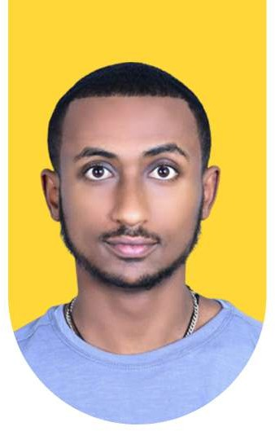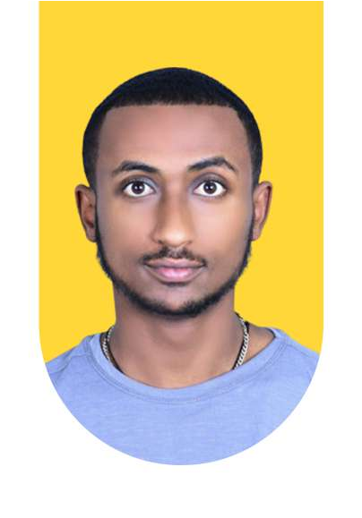

**CONTACT**

Addis Ababa, Ethiopia

+251933-902-180

[yeabsera550@gmail.com](mailto:yeabsera550@gmail.com)

**EDUCATION**

**Addis Ababa University** Chemical Engineering 2017- 2022 with 2.78 GPA

**LANGUAGE**

**AMHARIC -** NATIVE

**ENGLISH -** FLUENT

**REFERENCE**

**Mr. Simeneh Dagne** Human resource National Alcohol & Liquor Factory

+251913683488

**INTERESTS**

Reading Books Bodybuilding

Volunteer work Playing table tennis Learning New things Gardening